SIMATS ENGINEERING
SAVEETHA INSTITUTE OF MEDICAL AND TECHNICAL SCIENCES
CHENNAI – 602105
Department of Computer Science and Engineering

ASSESSMENT TOOL 1 – EXPLORATORY DATA ANALYSIS

Course Code | DSA05
Course Title | Query Processing for Data Science in Real Time Applications
CO Assessed | CO4
Assessment | Tool 1 – Exploratory Data Analysis
Total Marks | 25 Marks
Student Name | DENISHA SHREE R
Register Number | 192524016
Faculty Incharge | K. Veena Devi
Assessment Mode | Individual Submission

This report presents five independent Exploratory Data Analysis (EDA) exercises, each on a different publicly available dataset, covering Dataset Exploration, Data Cleaning, Statistical Analysis, Data Visualization, and Insights.

Titanic Passenger Survival Analysis
Dataset: Titanic Dataset. Explore passenger characteristics and determine factors associated with survival.

Dataset Exploration
import pandas as pd
df = pd.read_csv("titanic.csv") print(df.shape) print(df.head(10).to_string()) df.info()

Output

PassengerId Parch |  | Survived Ticket |  | Pclass  Fare Cabin Embarked |  |  | Name | Sex | Age | SibSp
0 | 1 |  | 0 |  | 3 |  | Braund, Mr. Owen Harris | male | 22.0 | 1
0 | A/5 21171 |  | 7.2500 |  | NaN | S
1 | 2 |  | 1 |  | 1 Cumings, Mrs. John Bradley (Florence Briggs Thayer) |  |  | female | 38.0 | 1
0 | PC 17599 |  | 71.2833 |  | C85 C
2 | 3 |  | 1 |  | 3 Heikkinen, Miss. Laina |  |  | female | 26.0 | 0
0 | STON/O2. 3101282 |  | 7.9250 |  | NaN S
3 | 4 |  | 1 |  | 1 Futrelle, Mrs. Jacques Heath (Lily May Peel) |  |  | female | 35.0 | 1
0 | 113803 |  | 53.1000 |  | C123 S
4 | 5 |  | 0 |  | 3 Allen, Mr. William Henry |  |  | male | 35.0 | 0
0 | 373450 |  | 8.0500 |  | NaN S
5 | 6 |  | 0 |  | 3 Moran, Mr. James |  |  | male | NaN | 0
0 | 330877 |  | 8.4583 |  | NaN Q
6 | 7 |  | 0 |  | 1 McCarthy, Mr. Timothy J |  |  | male | 54.0 | 0
0 | 17463 |  | 51.8625 |  | E46 S
7 | 8 |  | 0 |  | 3 Palsson, Master. Gosta Leonard |  |  | male | 2.0 | 3
1 | 349909 |  | 21.0750 |  | NaN S
8 | 9 |  | 1 |  | 3 Johnson, Mrs. Oscar W (Elisabeth Vilhelmina Berg) |  |  | female | 27.0 | 0
2 | 347742 |  | 11.1333 |  | NaN S
9 | 10 |  | 1 |  | 2 Nasser, Mrs. Nicholas (Adele Achem) |  |  | female | 14.0 | 1
0 | 237736 |  | 30.0708 |  | NaN C

Data Cleaning and Preparation

Shape: (891, 12)
Age: 714 non-null, Cabin: 204 non-null, Embarked: 889 non-null (rest full)
print(df.isnull().sum())
df['Age'] = df['Age'].fillna(df['Age'].median())
df['Embarked'] = df['Embarked'].fillna(df['Embarked'].mode()[0]) df.drop(columns=['Cabin'], inplace=True) print(df.duplicated().sum())

Output
Age
Cabin Embarked
177
687
2
(all other columns 0)

Duplicate rows: 0

Statistical Analysis
print(df[['Age','Fare','SibSp','Parch']].describe().round(2))
print(df.groupby('Sex')['Survived'].mean().round(3))
print(df.groupby('Pclass')['Survived'].mean().round(3)) print(df[['Survived','Pclass','Age','SibSp','Parch','Fare']].corr().round(2)) q1,q3 = df['Fare'].quantile([.25,.75]); iqr=q3-q1

print(((df['Fare']<q1-1.5*iqr)|(df['Fare']>q3+1.5*iqr)).sum())

Output
Age: mean 29.36 std 13.02 min 0.42 max 80.00
Fare: mean 32.20 std 49.69 min 0.00 max 512.33

Survival by Sex: female 0.742 male 0.189 Survival by Pclass: 1->0.630 2->0.473 3->0.242

Corr(Survived,Pclass) = -0.34 Corr(Survived,Fare) = 0.26
Corr(Pclass,Fare) = -0.55
Age outliers (IQR): 66
Fare outliers (IQR): 116

Data Visualization
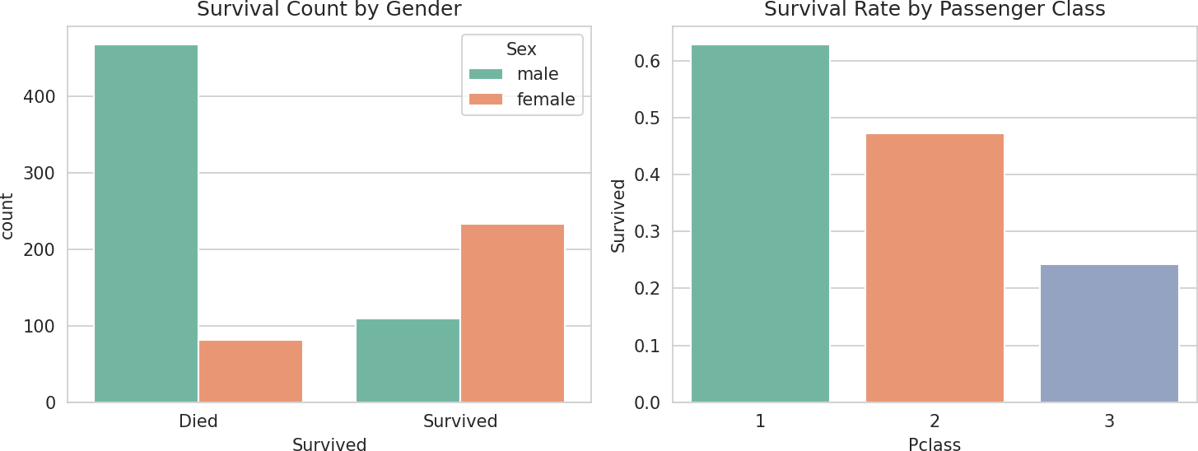
import seaborn as sns, matplotlib.pyplot as plt fig, axes = plt.subplots(1,2, figsize=(10,4))
sns.countplot(x='Survived', hue='Sex', data=df, ax=axes[0]) sns.barplot(x='Pclass', y='Survived', data=df, ax=axes[1]) plt.savefig('survival_gender_class.png')

Fig 1. Survival count by gender and survival rate by class.
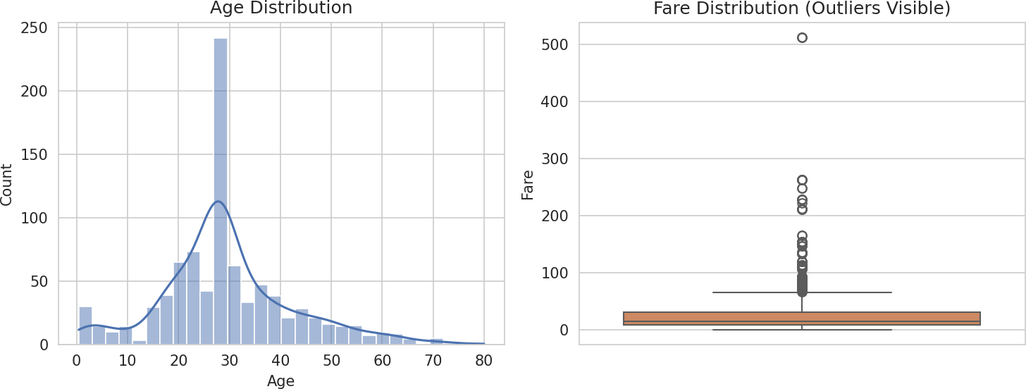
fig, axes = plt.subplots(1,2, figsize=(10,4)) sns.histplot(df['Age'], bins=30, kde=True, ax=axes[0]) sns.boxplot(y=df['Fare'], ax=axes[1]) plt.savefig('age_fare_dist.png')

Fig 2. Age distribution and Fare boxplot.
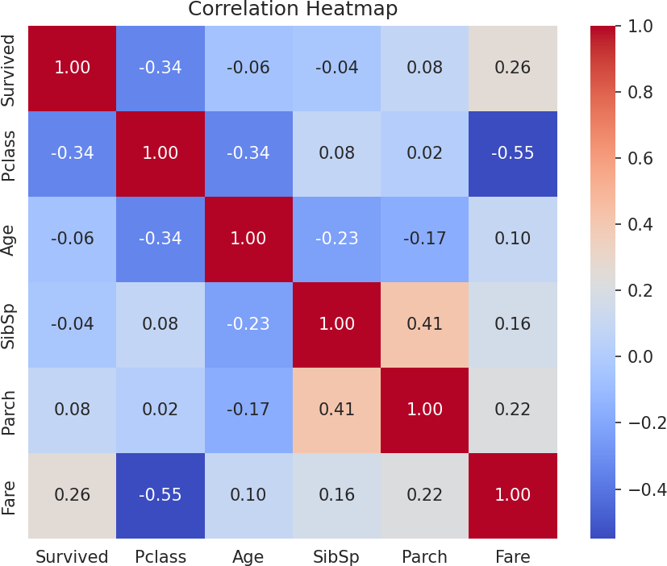
sns.heatmap(df[['Survived','Pclass','Age','SibSp','Parch','Fare']].corr(), annot=True, cmap='coolwarm')
plt.savefig('corr_heatmap.png')

Fig 3. Correlation heatmap.

Insights, Interpretation and Reporting
    - Gender was the strongest survival factor: women 74.2% vs men 18.9% survival.
    - Passenger class strongly predicted survival: 1st 63.0%, 2nd 47.3%, 3rd 24.2%.
    - Pclass and Fare are strongly negatively correlated (-0.55); Fare has weak positive correlation with survival.
    - Age shows little linear correlation with survival overall, though very young children fared better.
    - Fare and Age contain outliers (116 and 66 respectively); a few high fares correspond to genuine first-class bookings.
    - Sex, Pclass and Fare should be prioritized as leading predictive features in any survival model.

Employee Attrition Analysis
Dataset: IBM HR Employee Attrition Dataset. Investigate employee attrition patterns and identify major contributing factors.

Dataset Exploration
import pandas as pd
df = pd.read_csv("hr.csv") print(df.shape)
cols = ['Age','Attrition','Department','JobRole','MonthlyIncome','YearsAtCompany','OverTime','JobSatisfaction ']
print(df[cols].head(10).to_string())

Output

Age Attrition Department JobRole MonthlyIncome YearsAtCompany OverTime JobSatisfaction
0 | 41 | Yes | Sales | Sales Executive | 5993 | 6 | Yes
4
1 | 49 | No | Research & Development | Research Scientist | 5130 | 10 | No
2
2 | 37 | Yes | Research & Development | Laboratory Technician | 2090 | 0 | Yes
3
3 | 33 | No | Research & Development | Research Scientist | 2909 | 8 | Yes
3
4 | 27 | No | Research & Development | Laboratory Technician | 3468 | 2 | No
2
5 | 32 | No | Research & Development | Laboratory Technician | 3068 | 7 | No
4
6 | 59 | No | Research & Development | Laboratory Technician | 2670 | 1 | Yes
1
7 | 30 | No | Research & Development | Laboratory Technician | 2693 | 1 | No
3
8 | 38 | No | Research & Development | Manufacturing Director | 9526 | 9 | No
3
9 | 36 | No | Research & Development | Healthcare Representative | 5237 | 7 | No
3
Shape: (1470, 35)

Data Cleaning and Preparation
print(df.isnull().sum().sum()) print(df.nunique()[df.nunique()==1])
df = df.drop(columns=['EmployeeCount','Over18','StandardHours']) print(df.duplicated().sum())

Output
Total missing values: 0
Constant columns found: EmployeeCount, Over18, StandardHours (dropped - zero variance, no analytical value) Duplicate rows: 0

Statistical Analysis
print(df[['Age','MonthlyIncome','YearsAtCompany','DistanceFromHome']].describe().round(2)) print(df.groupby('Department')['Attrition'].apply(lambda s:(s=='Yes').mean()).round(3)) print(df.groupby('OverTime')['Attrition'].apply(lambda s:(s=='Yes').mean()).round(3))
num = df[['Age','MonthlyIncome','YearsAtCompany','JobSatisfaction','DistanceFromHome','TotalWorkingYears']] print(num.corr().round(2))

q1,q3 = df['MonthlyIncome'].quantile([.25,.75]); iqr=q3-q1 print(((df['MonthlyIncome']<q1-1.5*iqr)|(df['MonthlyIncome']>q3+1.5*iqr)).sum())

Output
MonthlyIncome: mean 6502.93 std 4707.96 min 1009 max 19999
YearsAtCompany: mean 7.01 std 6.13

Attrition by Department: HR 0.190 R&D 0.138 Sales 0.206 Attrition by OverTime: No 0.104 Yes 0.305

Corr(Age,MonthlyIncome)=0.50 Corr(MonthlyIncome,TotalWorkingYears)=0.77 Corr(JobSatisfaction, others) ~ 0.00 (near independent)

MonthlyIncome outliers (IQR): 114

Data Visualization
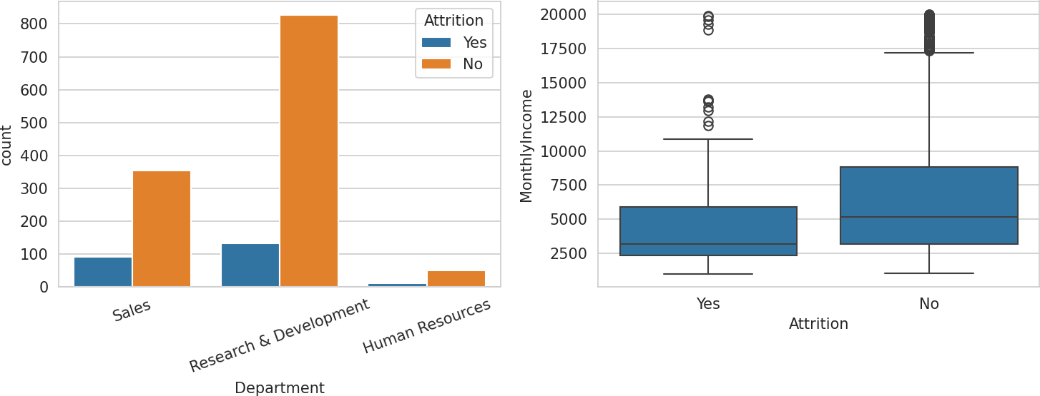
import seaborn as sns, matplotlib.pyplot as plt fig, axes = plt.subplots(1,2, figsize=(10,4))
sns.countplot(x='Department', hue='Attrition', data=df, ax=axes[0]) sns.boxplot(x='Attrition', y='MonthlyIncome', data=df, ax=axes[1]) plt.savefig('hr_attrition.png')

Fig 1. Attrition by department and income by attrition status.
sns.heatmap(num.corr(), annot=True, cmap='coolwarm') plt.savefig('hr_heatmap.png')

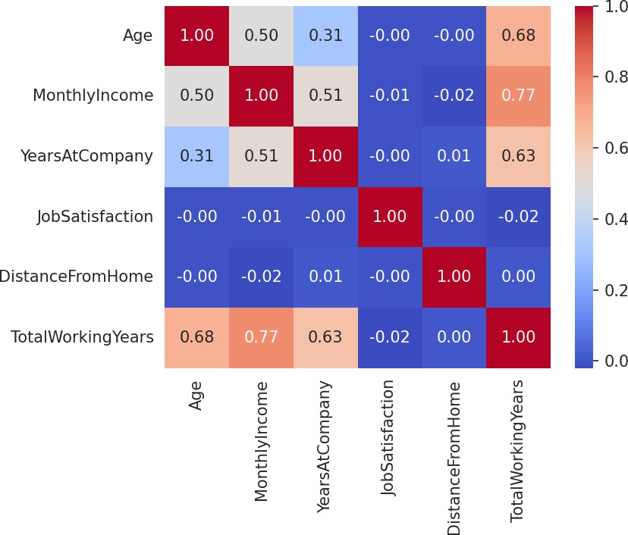

Fig 2. Correlation heatmap of key numeric features.

Insights, Interpretation and Reporting
    - Overtime is the single strongest attrition driver: 30.5% attrition for employees working overtime vs 10.4% for those who don't.
    - Sales has the highest departmental attrition rate (20.6%), followed by HR (19.0%); R&D is lowest (13.8%).
    - MonthlyIncome correlates strongly with TotalWorkingYears (0.77) and Age (0.50), as expected from tenure-based pay progression.
    - JobSatisfaction shows almost no linear correlation with the other numeric features, suggesting it is driven by factors not captured numerically (e.g. management, culture).
    - 114 employees are income outliers on the high end, mostly senior roles - expected and not data errors.
    - Recommendation: prioritize reducing mandatory overtime and review Sales compensation/workload to curb attrition.

Housing Price Analysis
Dataset: House Prices Dataset (California Housing). Explore housing market trends and identify factors affecting property prices.

Dataset Exploration
import pandas as pd
df = pd.read_csv("housing.csv") print(df.shape) print(df.head(10).to_string())

Output

8.3252 | 452600.0 | NEAR BAY
1 -122.22 | 37.86 | 21.0 | 7099.0 | 1106.0 | 2401.0 | 1138.0
8.3014 | 358500.0 | NEAR BAY
2 -122.24 | 37.85 | 52.0 | 1467.0 | 190.0 | 496.0 | 177.0
7.2574 | 352100.0 | NEAR BAY
3 -122.25 | 37.85 | 52.0 | 1274.0 | 235.0 | 558.0 | 219.0
5.6431 | 341300.0 | NEAR BAY
4 -122.25 | 37.85 | 52.0 | 1627.0 | 280.0 | 565.0 | 259.0
3.8462 | 342200.0 | NEAR BAY
5 -122.25 | 37.85 | 52.0 | 919.0 | 213.0 | 413.0 | 193.0
4.0368 | 269700.0 | NEAR BAY
6 -122.25 | 37.84 | 52.0 | 2535.0 | 489.0 | 1094.0 | 514.0
3.6591 | 299200.0 | NEAR BAY
7 -122.25 | 37.84 | 52.0 | 3104.0 | 687.0 | 1157.0 | 647.0
3.1200 | 241400.0 | NEAR BAY
8 -122.26 | 37.84 | 42.0 | 2555.0 | 665.0 | 1206.0 | 595.0
2.0804 | 226700.0 | NEAR BAY
9 -122.25 | 37.84 | 52.0 | 3549.0 | 707.0 | 1551.0 | 714.0
3.6912 | 261100.0 | NEAR BAY

Data Cleaning and Preparation
longitude latitude housing_median_age total_rooms total_bedrooms population households
median_income median_house_value ocean_proximity
0 -122.23 37.88 41.0 880.0 129.0 322.0 126.0
Shape: (20640, 10)
print(df.isnull().sum())
df['total_bedrooms'] = df['total_bedrooms'].fillna(df['total_bedrooms'].median()) print(df.duplicated().sum())

Output
total_bedrooms 207 (all other columns 0)

Duplicate rows: 0

Statistical Analysis
print(df.describe().round(2))
num = df.drop(columns=['ocean_proximity']) print(num.corr()['median_house_value'].round(2))
q1,q3 = df['median_house_value'].quantile([.25,.75]); iqr=q3-q1 print(((df['median_house_value']<q1-1.5*iqr)|(df['median_house_value']>q3+1.5*iqr)).sum()) q1,q3 = df['total_rooms'].quantile([.25,.75]); iqr=q3-q1
print(((df['total_rooms']<q1-1.5*iqr)|(df['total_rooms']>q3+1.5*iqr)).sum())

Output

median_house_value: mean 206855.82 std 115395.62 min 14999 max 500001
median_income: mean 3.87 std 1.90
Correlation with median_house_value: median_income 0.69
total_rooms 0.13
housing_median_age 0.11
latitude -0.14

median_house_value outliers (IQR): 1071 total_rooms outliers (IQR): 1287

Data Visualization
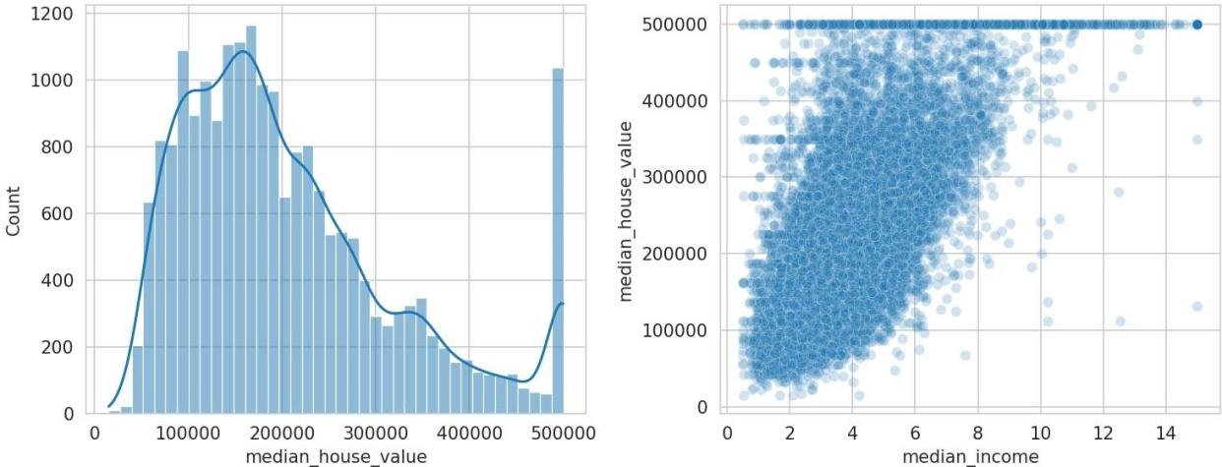
import seaborn as sns, matplotlib.pyplot as plt fig, axes = plt.subplots(1,2, figsize=(10,4))
sns.histplot(df['median_house_value'], bins=40, kde=True, ax=axes[0]) sns.scatterplot(x='median_income', y='median_house_value', data=df, alpha=0.2, ax=axes[1]) plt.savefig('housing_dist.png')

Fig 1. Price distribution and income vs price scatter.
sns.heatmap(num.corr(), annot=True, cmap='coolwarm') plt.savefig('housing_heatmap.png')

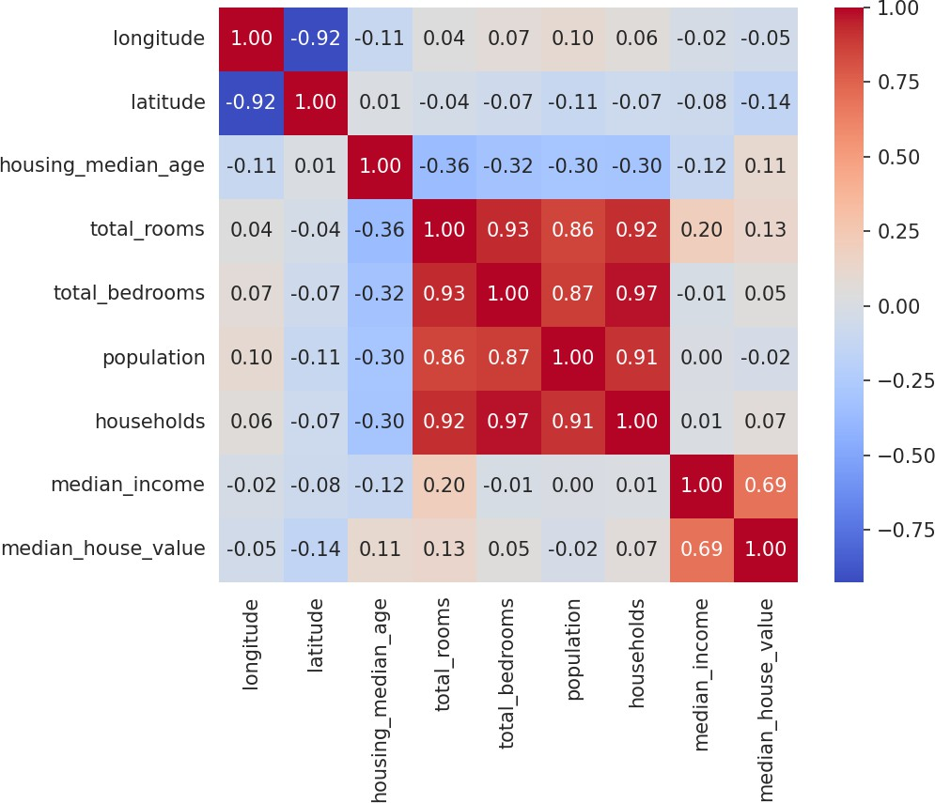

Fig 2. Correlation heatmap of numeric housing features.

Insights, Interpretation and Reporting
    - median_income is by far the strongest predictor of median_house_value (correlation 0.69).
    - median_house_value is capped at 500,001 - visible as a spike at the right edge of the histogram, a known artifact of this dataset requiring careful handling in modeling.
    - total_rooms and total_bedrooms have many high-end outliers (1287 for rooms), consistent with a mix of small and very large residential blocks.
    - Geographic features (latitude/longitude) show weak individual correlation with price, but location matters heavily in combination (coastal proximity, seen via ocean_proximity categories).
    - Recommendation: cap or transform median_house_value, engineer rooms-per-household and bedrooms-per-room ratios, and treat location as a categorical/spatial feature rather than raw coordinates.

COVID-19 Data Exploration
Dataset: COVID-19 Global Cases Dataset. Analyze COVID-19 statistics across countries and identify significant trends.

Dataset Exploration
import pandas as pd
df = pd.read_csv("covid.csv") print(df.shape)
cols = ['location','continent','total_cases','total_deaths','new_cases','new_deaths','population','total_case s_per_million']
print(df[cols].head(10).to_string())

Output

location |  | continent | total_cases | total_deaths | new_cases | new_deaths | population
total_cases_per_million
- Afghanistan  5796.468  - Africa |  | Asia  NaN | 235214.0  13145380.0 | 7998.0  259117.0 | 0.0  36.0 | 0.0  0.0 | 4.112877e+07  1.426737e+09
9088.877
- Albania  118491.020  - Algeria |  | Europe  Africa | 335047.0  272139.0 | 3605.0  6881.0 | 0.0  18.0 | 0.0  0.0 | 2.842318e+06  4.490323e+07
5984.050  4 American Samoa |  | Oceania | 8359.0 | 34.0 | 0.0 | 0.0 | 4.429500e+04
172831.600
5 | Andorra | Europe | 48015.0 | 159.0 | 0.0 | 0.0 | 7.984300e+04
602280.440
6 | Angola | Africa | 107481.0 | 1937.0 | 0.0 | 0.0 | 3.558900e+07
3016.162
7 | Anguilla | North America | 3904.0 | 12.0 | 0.0 | 0.0 | 1.587700e+04
274890.880  8 Antigua | and Barbuda | North America | 9106.0 | 146.0 | 0.0 | 0.0 | 9.377200e+04
98071.100
9 | Argentina | South America | 10101218.0 | 130663.0 | 54.0 | 1.0 | 4.551032e+07
222455.060

Data Cleaning and Preparation
Shape: (247, 67)
df2 = df[df['continent'].notna()].copy()
df2[['total_cases','total_deaths']] = df2[['total_cases','total_deaths']].fillna(0) print(df2.duplicated().sum())
print(df2.shape)

Output
Removed 12 aggregate rows with continent = NaN (e.g. 'World', 'Africa' region totals) Duplicate rows: 0
Shape after cleaning: (235, 67)

Statistical Analysis
print(df2[['total_cases','total_deaths','population']].describe().round(2)) df2['death_rate'] = (df2['total_deaths']/df2['total_cases']*100).round(2) top10 =
df2.nlargest(10,'total_cases')[['location','total_cases','total_deaths','death_rate']] print(top10.to_string()) print(df2[['total_cases','total_deaths','population']].corr().round(2))

Output
total_cases: mean 3,301,561 max 103,436,829 (USA)

Top 10 by total_cases:
United States 103.4M | China 99.4M | India 45.0M | France 39.0M | Germany 38.4M Brazil 37.5M | South Korea 34.6M | Japan 33.8M | Italy 26.8M | UK 25.0M
Death rates: Brazil 1.87% India 1.18% USA 1.15% UK 0.93% China 0.12% Corr(total_cases,total_deaths)=0.77 Corr(total_cases,population)=0.70

Data Visualization
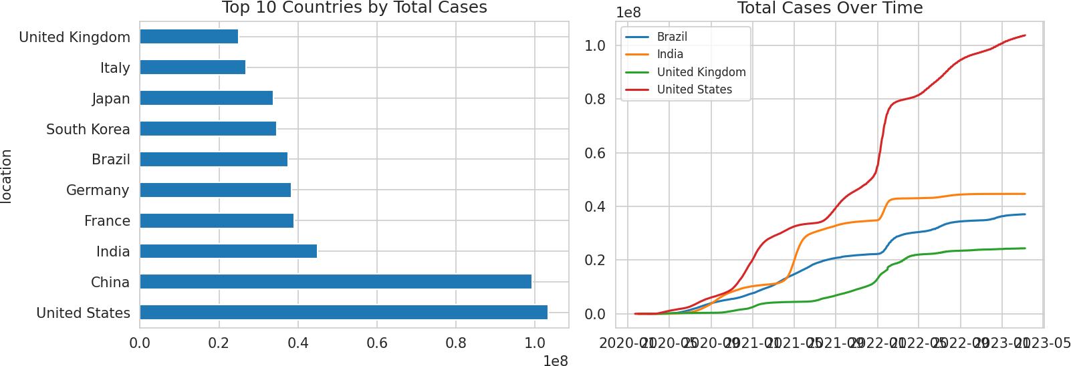
top10.set_index('location')['total_cases'].plot(kind='barh') plt.savefig('top10_cases.png')

Fig 1. Top 10 countries by total cases (left) and total-case trend over time for four countries (right).
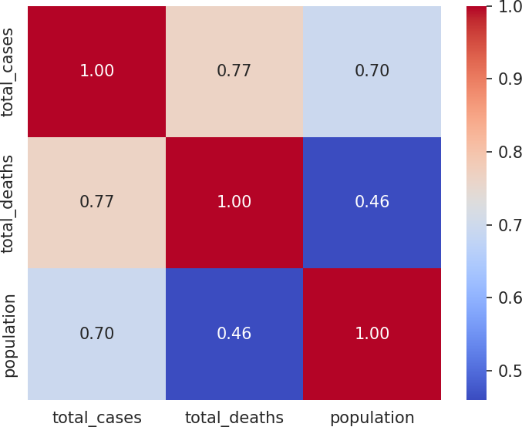
import seaborn as sns sns.heatmap(df2[['total_cases','total_deaths','population']].corr(), annot=True, cmap='coolwarm')
plt.savefig('covid_heatmap.png')

Fig 2. Correlation heatmap of case, death and population figures.

Insights, Interpretation and Reporting
    - The United States, China and India lead in absolute case counts, but this largely reflects population size and testing capacity, not just outbreak severity.
    - Death rate varies substantially by country - Brazil (1.87%) and India (1.18%) are notably higher than China (0.12%) and South Korea (0.10%), reflecting differences in healthcare capacity and reporting.
    - Total cases and total deaths are strongly correlated (0.77), as expected, but population size alone explains a meaningful share of case variation (0.70).
    - 39 countries are statistical outliers on total_cases via the IQR method - large countries dominate the distribution's upper tail.
    - Time-trend plots for the US, India, Brazil and UK show distinct pandemic waves at different points, underscoring that a single global snapshot understates the staggered nature of the pandemic.
    - Recommendation: normalize comparisons per-capita (cases/deaths per million) rather than using absolute totals when ranking countries.

Automobile Market Analysis
Dataset: Automobile MPG Dataset. Investigate vehicle characteristics and fuel efficiency trends.

Dataset Exploration
import pandas as pd
df = pd.read_csv("mpg.csv") print(df.shape) print(df.head(10).to_string())

Output
mpg cylinders displacement horsepower weight acceleration model-year
0 18.0 8 307.0 130.0 3504 12.0 70
1 15.0 8 350.0 165.0 3693 11.5 70
2 18.0 8 318.0 150.0 3436 11.0 70
3 16.0 8 304.0 150.0 3433 12.0 70
4 17.0 8 302.0 140.0 3449 10.5 70
5 15.0 8 429.0 198.0 4341 10.0 70
6 14.0 8 454.0 220.0 4354 9.0 70
7 14.0 8 440.0 215.0 4312 8.5 70
8 14.0 8 455.0 225.0 4425 10.0 70
9 15.0 8 390.0 190.0 3850 8.5 70

Shape: (398, 7)

Data Cleaning and Preparation
print(df.isnull().sum())
df['horsepower'] = df['horsepower'].fillna(df['horsepower'].median()) print(df.duplicated().sum())

Output
horsepower 2 (all other columns 0)
Rows 32 and 126 had missing horsepower - imputed with the column median (92.0)

Duplicate rows: 0

Statistical Analysis
print(df.describe().round(2)) print(df.corr(numeric_only=True).round(2))
q1,q3 = df['horsepower'].quantile([.25,.75]); iqr=q3-q1 print(((df['horsepower']<q1-1.5*iqr)|(df['horsepower']>q3+1.5*iqr)).sum()) q1,q3 = df['mpg'].quantile([.25,.75]); iqr=q3-q1
print(((df['mpg']<q1-1.5*iqr)|(df['mpg']>q3+1.5*iqr)).sum())

Output
mpg: mean 23.51 std 7.82 min 9.00 max 46.60
weight: mean 2970.42 std 846.84
horsepower: mean 104.19 std 38.40

Corr(mpg,weight)=-0.83 Corr(mpg,displacement)=-0.80 Corr(mpg,cylinders)=-0.78 Corr(mpg,horsepower)=-0.78 Corr(weight,displacement)=0.93 Corr(cylinders,displacement)=0.95
Horsepower outliers (IQR): 10
MPG outliers (IQR): 1

Data Visualization

import seaborn as sns, matplotlib.pyplot as plt fig, axes = plt.subplots(1,2, figsize=(10,4))
sns.scatterplot(x='weight', y='mpg', hue='cylinders', data=df, palette='viridis', ax=axes[0])
sns.boxplot(x='cylinders', y='mpg', data=df, ax=axes[1]) plt.savefig('mpg_scatter.png')
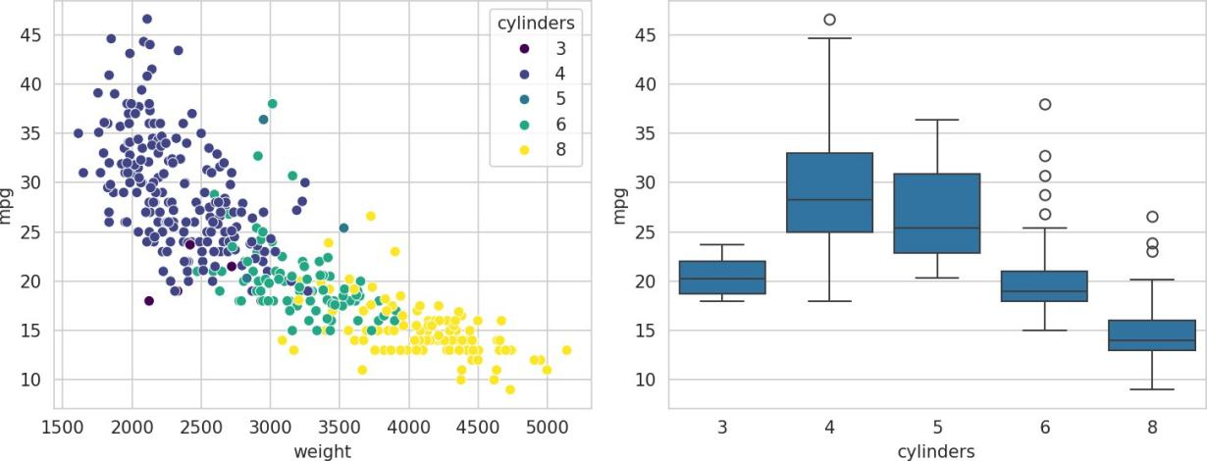

Fig 1. Weight vs MPG scatter and MPG distribution by cylinder count.
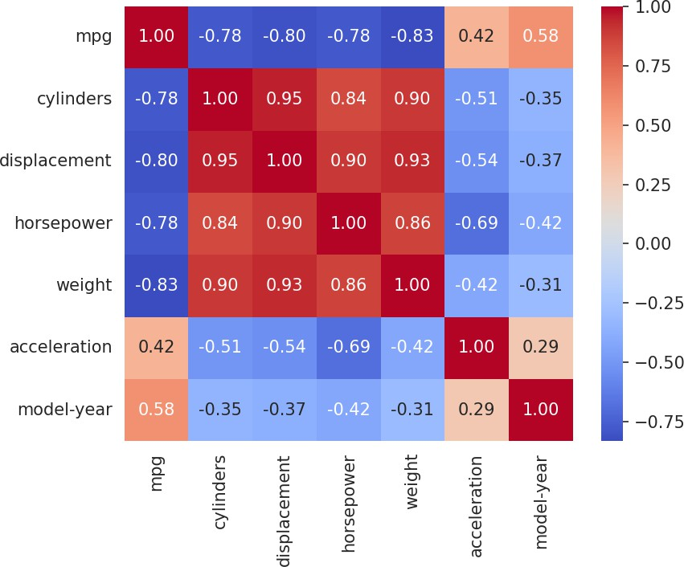
sns.heatmap(df.corr(numeric_only=True), annot=True, cmap='coolwarm') plt.savefig('mpg_heatmap.png')

Fig 2. Correlation heatmap of vehicle attributes.

Insights, Interpretation and Reporting
    - Vehicle weight is the strongest negative predictor of fuel efficiency (correlation -0.83) - heavier cars consistently return lower MPG.
    - Cylinders, displacement, weight and horsepower are all highly inter-correlated (0.84-0.95), reflecting that larger engines drive larger, heavier vehicles.

    - 4-cylinder vehicles show a much higher median MPG and wider spread than 6- and 8-cylinder vehicles, which cluster tightly at lower MPG.
    - model-year has a positive correlation with mpg (0.58), showing a clear efficiency improvement trend across model years (1970-1982), likely driven by post-oil-crisis fuel economy standards.
    - Only 2 missing horsepower values and 10 horsepower outliers were found - the dataset is largely clean, with outliers corresponding to genuine high-performance engines.
    - Recommendation: weight and model-year are the two features that would add the most predictive value in an MPG estimation model.

